Pizza Sales SQL Queries
A KPI’s
1.Total Revenue
select sum(total_price) as Total_Revenue from pizza_sales
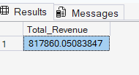
2.Average Order Value:
select sum(total_price)/count(distinct(Order_id)) as avg_order_value from pizza_sales
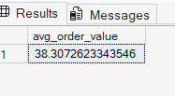
3.Total Pizza Sold:
select sum(quantity) as Total_Pizza_Sold from pizza_sales
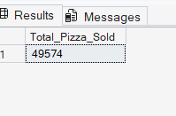
4.Total Orders
select count(distinct(Order_id)) as Total_Orders from pizza_sales
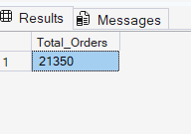
5.Average Pizza per Order
select CAST(CAST(sum(quantity)AS DECIMAL(10,2))/CAST(count(distinct(order_id)) AS decimal(10,2)) AS decimal(10,2)) AS Avg_pizzas_per_order from pizza_sales
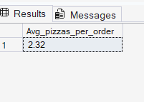
Chart Requirment
1.Daily Trend for Total Order
select datename(dw,Order_date) as order_day,count(distinct(order_id)) as total_orders
from pizza_sales group by datename(dw,Order_date)
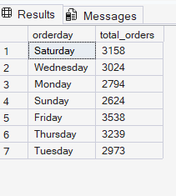
2.Monthly Trend For Total Orders
select datename(month,Order_date) as Month_name,count(distinct(order_id)) as total_orders
from pizza_sales group by datename(month,Order_date) order by Total_Orders desc
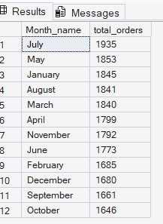
3.% of Sales By Pizza Category
SELECT pizza_category, CAST(SUM(total_price) AS DECIMAL(10,2)) as total_revenue,
CAST(SUM(total_price) * 100 / (SELECT SUM(total_price) from pizza_sales) AS DECIMAL(10,2)) AS PCT
FROM pizza_sales
GROUP BY pizza_category
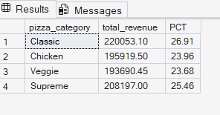
4.% of Sales By Pizza Size
SELECT pizza_size, CAST(SUM(total_price) AS DECIMAL(10,2)) as total_revenue,
CAST(SUM(total_price) * 100 / (SELECT SUM(total_price) from pizza_sales) AS DECIMAL(10,2)) AS PCT
FROM pizza_sales
GROUP BY pizza_size
order by pct desc
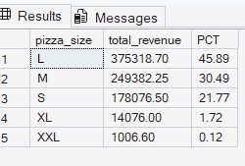
5.Total Pizza Sold By Pizza Category
select pizza_category, sum(quantity) as Total_Quantity_Sold from pizza_sales
where month(order_date)=2group by pizza_category order by Total_Quantity_Sold desc
6.Top 5 Pizza by Revenue
select top 5 pizza_name, cast(sum(total_price) as dec(10,2)) as Total_Revenue from pizza_sales
group by pizza_name
order by total_Revenue desc
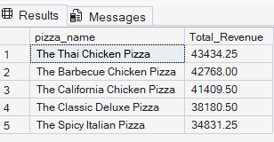
7.Bottom 5 Pizza by Revenue
select top 5 pizza_name,cast(sum(total_price)as dec(10,2)) as Total_Revenue from pizza_sales
group by pizza_name
order by total_Revenue
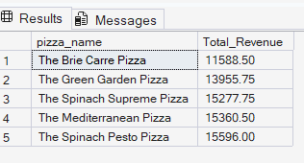
8.Top 5 Pizza by Quantity
select top 5 pizza_name,sum(quantity) as Total_Pizza_Sold from pizza_sales
group by pizza_name
order by Total_Pizza_Sold desc
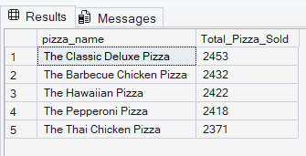
9.Bottom 5 Pizza by Quantity
select top 5 pizza_name,sum(quantity) as Total_Pizza_Sold from pizza_sales
group by pizza_name
order by Total_Pizza_Sold asc
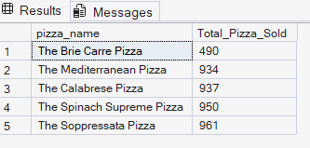
10.Top 5 Pizza by Total Order
select top 5 pizza_name,count(Order_id) as Total_Order from pizza_sales
group by pizza_name order by Total_Order desc
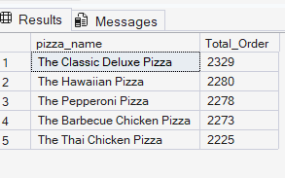
11.Bottom 5 Pizza by Total Order
select top 5 pizza_name,count(Order_id) as Total_Order from pizza_sales
group by pizza_name order by Total_Order asc
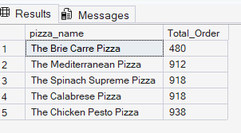
Note
If you want to apply the pizza_category or pizza_size filters to the above queries you can use WHERE clause. Follow some of below examples
SELECT Top 5 pizza_name, COUNT(DISTINCT order_id) AS Total_Orders
FROM pizza_sales
WHERE pizza_category = 'Classic'
GROUP BY pizza_name
ORDER BY Total_Orders ASC

